A lab report on Deterministic Adversarial Search

Questions

By : Abdi Hadra
AI Department
Addis Ababa Institute of Technology
Introduction:
overview
in this lab assignment we are required to implement mini-max algorithm in the game of tictactoe. in the first stage we will just demonstrate the working of mini-max algorithm in the game and in the second we will include more advanced method using heuristic evaluation function and make the program unbeatable ,in the third lab assignment we will demonstrate alpha-beta pruning in the minimax algorithm for the game
objectives
the goal and objective of this assignment is to help us further understand the minimax algorithm, and perhaps show how to dominate at a game of tic tac toe and see how alpha-beta pruning can decrease the number of nodes
Problem Statement
there are three problems in this lab assignment
1.in the first assignment we will try to implement minimax algorithm in tictactoe game and we make our program just to pick the optimal move and show the path2. in the second lab assignment we will use minimax algorithm with heuristic evaluation function to make an unbeatable program in the game of tictactoe
3. in the third lab we will use alpha-beta pruning in the minimax algorithm for the game of chess,since chess has many possible moves we will use alpha-beta pruning method to play
Methodology or Algorithm Description
The key to the Minimax algorithm is a back and forth between the two players, where the player whose "turn it is" desires to pick the move with the maximum score. In turn, the scores for each of the available moves are determined by the opposing player deciding which of its available moves has the minimum score. And the scores for the opposing players moves are again determined by the turn-taking player trying to maximize its score and so on all the way down the move tree to an end state.
A description for the algorithm, assuming X is the "turn taking player," would look something like:
- If the game is over, return the score from X's perspective.
- Otherwise get a list of new game states for every possible move
- Create a scores list
- For each of these states add the minimax result of that state to the scores list
- If it's X's turn, return the maximum score from the scores list
- If it's O's turn, return the minimum score from the scores list
You'll notice that this algorithm is recursive, it flips back and forth between the players until a final score is found.
Let's walk through the algorithm's execution with the full move tree, and show why, algorithmically, the instant winning move will be picked:

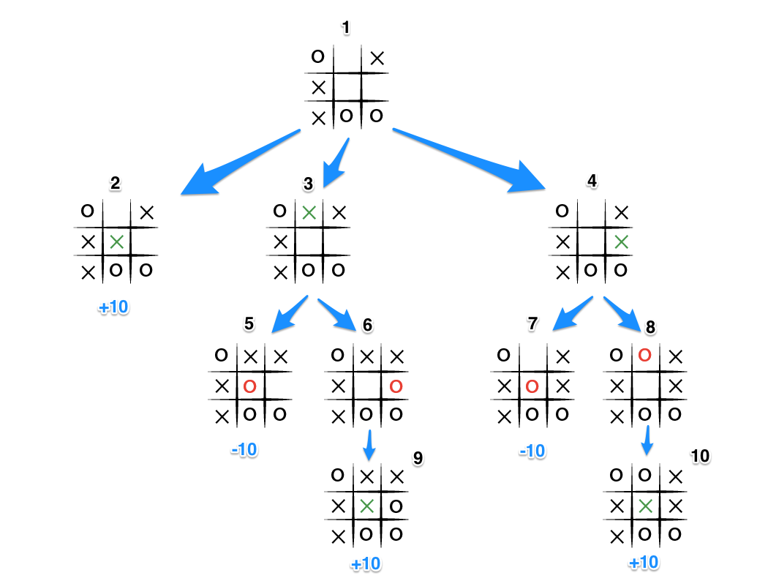

- It's X's turn in state 1. X generates the states 2, 3, and 4 and calls minimax on those states.
- State 2 pushes the score of +10 to state 1's score list, because the game is in an end state.
- State 3 and 4 are not in end states, so 3 generates states 5 and 6 and calls minimax on them, while state 4 generates states 7 and 8 and calls minimax on them.
- State 5 pushes a score of -10 onto state 3's score list, while the same happens for state 7 which pushes a score of -10 onto state 4's score list.
- State 6 and 8 generate the only available moves, which are end states, and so both of them add the score of +10 to the move lists of states 3 and 4.
- Because it is O's turn in both state 3 and 4, O will seek to find the minimum score, and given the choice between -10 and +10, both states 3 and 4 will yield -10.
- Finally the score list for states 2, 3, and 4 are populated with +10, -10 and -10 respectively, and state 1 seeking to maximize the score will chose the winning move with score +10, state 2.
That is certainly a lot to take in. And that is why we have a computer execute this algorithm.
##A Coded Version of Minimax Hopefully by now you have a rough sense of how th e minimax algorithm determines the best move to play. Let's examine my implementation of the algorithm to solidify the understanding:
Here is the function for scoring the game:
# @player is the turn taking player
def score(game)
if game.win?(@player)
return 10
elsif game.win?(@opponent)
return -10
else
return 0
end
end
Simple enough, return +10 if the current player wins the game, -10 if the other player wins and 0 for a draw. You will note that who the player is doesn't matter. X or O is irrelevant, only who's turn it happens to be.
And now the actual minimax algorithm; note that in this implementation a choice or move is simply a row / column address on the board, for example [0,2] is the top right square on a 3x3 board.
def minimax(game)
return score(game) if game.over?
scores = [] # an array of scores
moves = [] # an array of moves

# Populate the scores array, recursing as needed
game.get_available_moves.each do |move|
possible_game = game.get_new_state(move)
scores.push minimax(possible_game)
moves.push move
end

# Do the min or the max calculation
if game.active_turn == @player
# This is the max calculation
max_score_index = scores.each_with_index.max[1]
@choice = moves[max_score_index]
return scores[max_score_index]
else
# This is the min calculation
min_score_index = scores.each_with_index.min[1]
@choice = moves[min_score_index]
return scores[min_score_index]
end
end
When this algorithm is run inside a PerfectPlayer class, the ultimate choice of best move is stored in the @choice variable, which is then used to return the new game state in which the current player has moved.
##A Perfect but Fatalist Player Implementing the above algorithm will get you to a point where your tic tac toe game can't be beat. But and interesting nuance that I discovered while testing is that a perfect player must always be perfect. In other words, in a situation where the perfect player eventually will lose or draw, the decisions on the next move are rather fatalistic. The algorithm essentially says: "hey I'm gonna lose anyway, so it really doesn't matter if I lose in the next more or 6 moves from now."
I discovered this by passing an obviously rigged board, or one with a "mistake" in it to the algorithm and asked for the next best move. I would have expected the perfect player to at least put up a fight and block my immediate win. It however, did not:
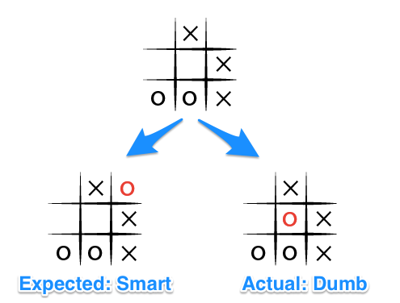
Let's see what is happening here by looking through the possible move tree (Note, I've removed some of the possible states for clarity):
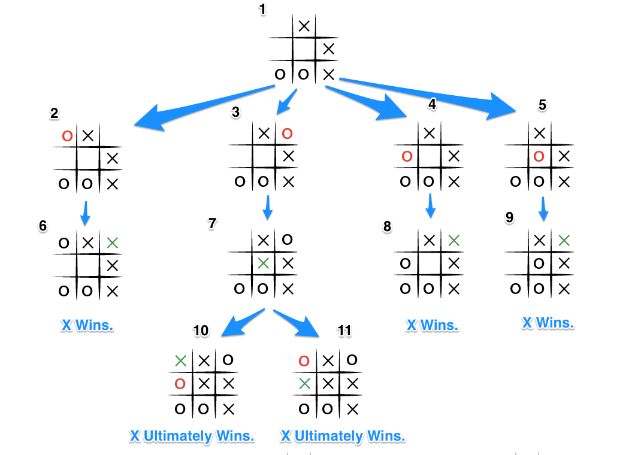
Given the board state 1 where both players are playing perfectly, and O is the computer player. O choses the move in state 5 and then immediately loses when X wins in state 9.
- But if O blocks X's win as in state 3, X will obviously block O's potential win as shown in state 7.
- This puts two certain wins for X as shown in state 10 and 11, so no matter which move O picks in state 7, X will ultimately win.
As a result of these scenarios, and the fact that we are iterating through each blank space, from left to right, top to bottom, all moves being equal, that is, resulting in a lose for O, the last move will be chosen as shown in state 5, as it is the last of the available moves in state 1. The array of moves being: [top-left, top-right, middle-left, middle-center].

Conclusion
All of the above helped me further understand the minimax algorithm, and perhaps how to dominate at a game of tic tac toe. And we can clearly see that we can use minimax algorithms in any game and real environment that have similar problems like the tic tac toe ,and also alphabeta pruning helped decrease the number of nodes that are evaluated by the minimax algorithm in its search tree

